Created a cheater for interaction:

Sigma: 14

First run: **LSTAR** and **RandomWalk**:

|  |  |
| --- | --- |
| #Queries | 1778 |
| #C | 0 |
| States | 9 |
| Transitions | 25 |
| QueryStatistics | {1=1780, 2=1766, 3=1570, 4=786, 5=2, 6=2, 7=2, 8=2, 9=2, 10=2, 11=2, 12=1, 13=1, 14=1, 15=1, 16=1, 17=1, 18=1, 19=1, 20=1, 21=1, 22=1, 23=1, 24=1, 25=1, 26=1, 27=1, 28=1, 29=1} |
|  |  |
| Log | graph_1511175460101 |
| DFA | digraph g {  __stadigraph g {  __start0 [label="" shape="none"];  s0 [shape="circle" label="0"];  s1 [shape="circle" label="1"];  s2 [shape="circle" label="2"];  s3 [shape="circle" label="3"];  s4 [shape="circle" label="4"];  s5 [shape="circle" label="5"];  s6 [shape="circle" label="6"];  s7 [shape="circle" label="7"];  s8 [shape="circle" label="8"];  s0 -> s1 [label="push-row_button_From- 0-OK"];  s0 -> s2 [label="push-row_button_To- 0-OK"];  s0 -> s3 [label="push-row_button_When- 0-OK"];  s0 -> s0 [label="push-planJourney_button- 0-OK"];  s0 -> s4 [label="check-toggleOptions_button- 0-OK"];  s0 -> s0 [label="push-extraCommand- 0-OK"];  s1 -> s5 [label="push-sectionedlocation_item_title- 0-OK"];  s1 -> s6 [label="enterText-locationpicker_searchbox#Amsterdam/ 0-OK"];  s2 -> s7 [label="push-sectionedlocation_item_title- 0-OK"];  s2 -> s8 [label="enterText-locationpicker_searchbox#Rotterdam/ 0-OK"];  s4 -> s4 [label="push-planJourney_button- 0-OK"];  s4 -> s0 [label="check-toggleOptions_button- 0-OK"];  s4 -> s4 [label="check-requireAccessibleForDisabeled- 0-OK"];  s4 -> s4 [label="check-transferTime_checkbox- 0-OK"];  s4 -> s4 [label="push-extraCommand- 0-OK"];  s5 -> s2 [label="push-row_button_To- 0-OK"];  s5 -> s3 [label="push-planJourney_button- 0-OK"];  s5 -> s4 [label="check-toggleOptions_button- 0-OK"];  s5 -> s5 [label="push-extraCommand- 0-OK"];  s6 -> s5 [label="push-sectionedlocation_item_title- 0-OK"];  s7 -> s1 [label="push-row_button_From- 0-OK"];  s7 -> s3 [label="push-planJourney_button- 0-OK"];  s7 -> s4 [label="check-toggleOptions_button- 0-OK"];  s7 -> s7 [label="push-extraCommand- 0-OK"];  s8 -> s7 [label="push-sectionedlocation_item_title- 0-OK"];  __start0 -> s0;  }start0 -> s0;  } |

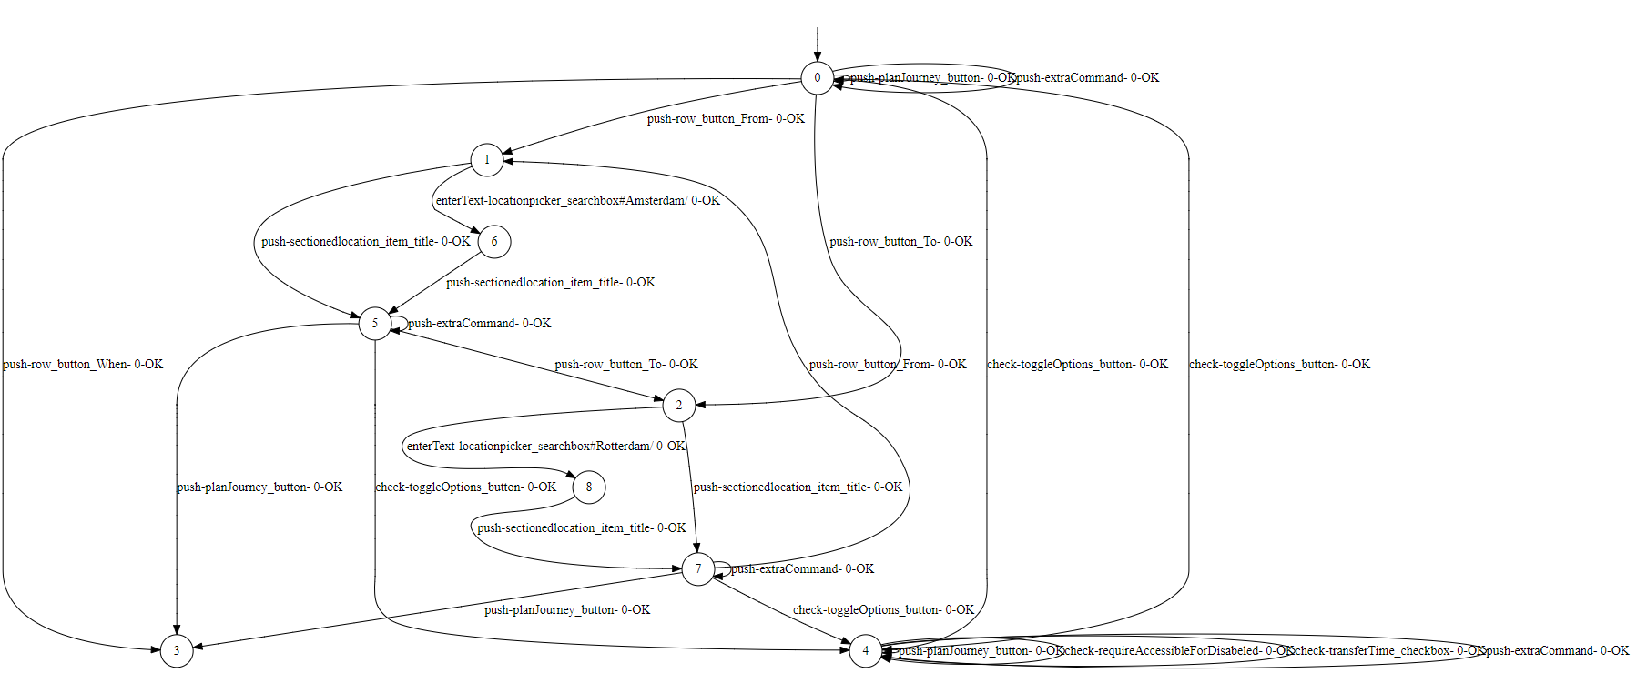

First run: TTT and RandomWalk:

|  |  |
| --- | --- |
| #Queries | 55 |
| #C | {2=2} |
| States | 2 |
| Transitions | 6 |
| QueryStatistics | {1=57, 2=43, 3=15, 4=1, 5=1, 6=1, 7=1, 8=1, 9=1, 10=1, 11=1, 12=1, 13=1, 14=1, 15=1, 16=1, 17=1, 18=1, 19=1, 20=1, 21=1, 22=1, 23=1, 24=1, 25=1, 26=1, 27=1, 28=1, 29=1, 30=1, 31=1, 32=1, 33=1, 34=1, 35=1, 36=1, 37=1, 38=1} |
|  |  |
| Log | graph_1511175460101 |
| DFA | digraph g {  digraph g {  __start0 [label="" shape="none"];  s0 [shape="circle" label="s0"];  s1 [shape="circle" label="s1"];  s0 -> s1 [label="push-row_button_From- 0-OK"];  s0 -> s1 [label="push-row_button_To- 0-OK"];  s0 -> s1 [label="push-row_button_When- 0-OK"];  s0 -> s0 [label="push-planJourney_button- 0-OK"];  s0 -> s1 [label="check-toggleOptions_button- 0-OK"];  s0 -> s0 [label="push-extraCommand- 0-OK"];  __start0 -> s0;  } |

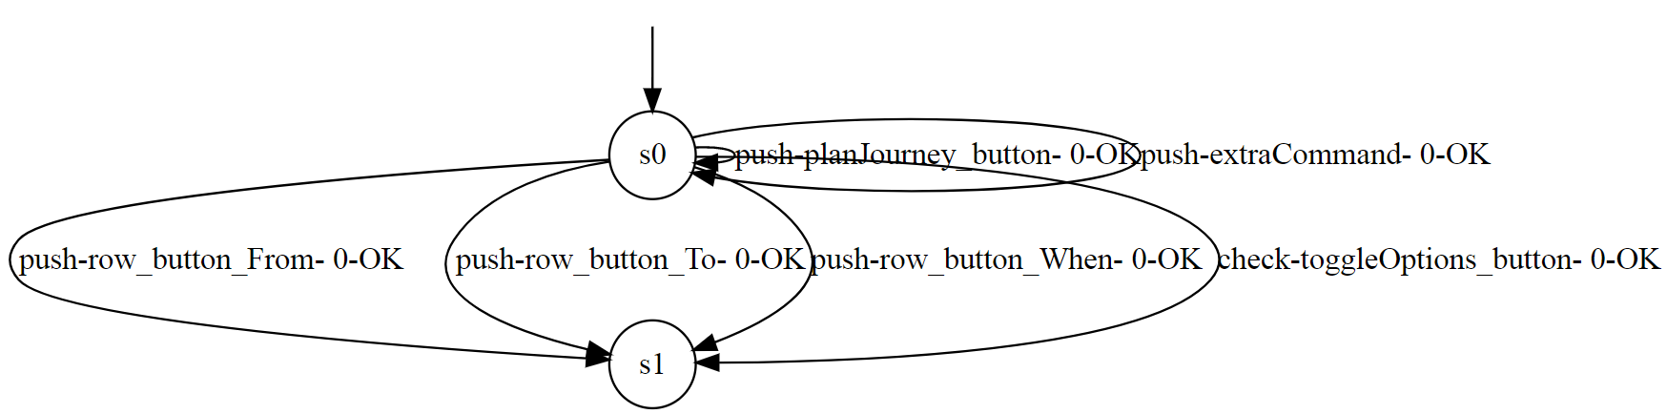

First run: TTT and CustomRandomWalk:

|  |  |
| --- | --- |
| #Queries | 55 |
| #C | {2=2} |
| States | 2 |
| Transitions | 6 |
| QueryStatistics | {1=57, 2=43, 3=15, 4=1, 5=1, 6=1, 7=1, 8=1, 9=1, 10=1, 11=1, 12=1, 13=1, 14=1, 15=1, 16=1, 17=1, 18=1, 19=1, 20=1, 21=1, 22=1, 23=1, 24=1, 25=1, 26=1, 27=1, 28=1, 29=1, 30=1, 31=1, 32=1, 33=1, 34=1, 35=1, 36=1, 37=1, 38=1} |
|  |  |
| Log | graph_1511175460101 |
| DFA | digraph g {  digraph g {  __start0 [label="" shape="none"];  s0 [shape="circle" label="s0"];  s1 [shape="circle" label="s1"];  s0 -> s1 [label="push-row_button_From- 0-OK"];  s0 -> s1 [label="push-row_button_To- 0-OK"];  s0 -> s1 [label="push-row_button_When- 0-OK"];  s0 -> s0 [label="push-planJourney_button- 0-OK"];  s0 -> s1 [label="check-toggleOptions_button- 0-OK"];  s0 -> s0 [label="push-extraCommand- 0-OK"];  __start0 -> s0;  } |